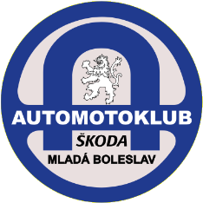
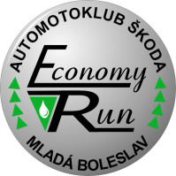
35th year of the
ŠKODA Economy Run
Kosmonosy – Vrchlabí – Kosmonosy
24th of September 2016

Driver T-shirt size
Last name : First name : S M L XL XXL
Navigator T-shirt size
Last name : First name : S M L XL XXL
Vehicle
Please, note, that you must attach a copy of the certificate of roadworthiness (technical specification of competing car and its standard consumption) to the filled application form.
Please notice the Paragraph 3 of Propositions with the restriction for competing car !!
We are representing
Town :
Journal / Dealer/ Škoda department :
Contact :
Name : Street, no. :
Town : ZIP :
E-mail : Phone :
GSM : Fax :
By sending this application we agree to be bound by the Regulations and we are fully acquainted with.

